St. Mochuo’s School
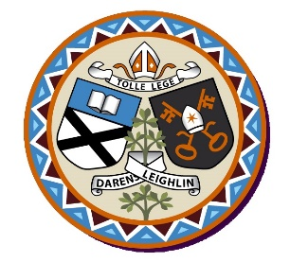
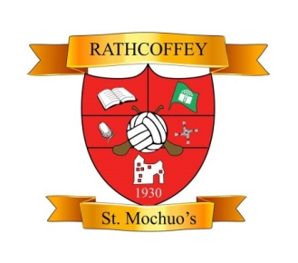
Rathcoffey, Donadea, Naas,
Co. Kildare W91 W012
Phone: 045 868721
Email: rathcoffeyschool@yahoo.ie
Charity No. 20124465
ANNUAL ADMISSION NOTICE
in respect of admissions to the 2026-2027 school year
Admission Policy and Application Form
A copy of the school’s Admission Policy and the Application Form for Admission for the 2026-2027 school year is available as follows: –

To download at: www.rathcoffeyns.ie

PART 1: ADMISSIONS TO THE 2026/2027 SCHOOL YEAR
Application and Decision Dates for admission to 2026/2027 school year
The following are the dates applicable for admission to Junior Infants
The school will commence accepting applications for admission on | 06/10/2025
The school shall cease accepting applications for admission on | 24/10/2025
The date by which applicants will be notified of the decision on their application is | 14/11/2025
The period within which applicants must confirm acceptance of an offer of admission is | 21/11/2025

Note: the school will consider and issue decisions on late applications in accordance with the school’s admission policy.

Failure to accept an offer within the prescribed period above may result in the offer being withdrawn

NUMBER OF PLACES BEING MADE AVAILABLE IN 2026/2027 SCHOOL YEAR
The number of places being made available in Junior Infants | 23

